***Dharmathej S K***

Project Name: Netflix

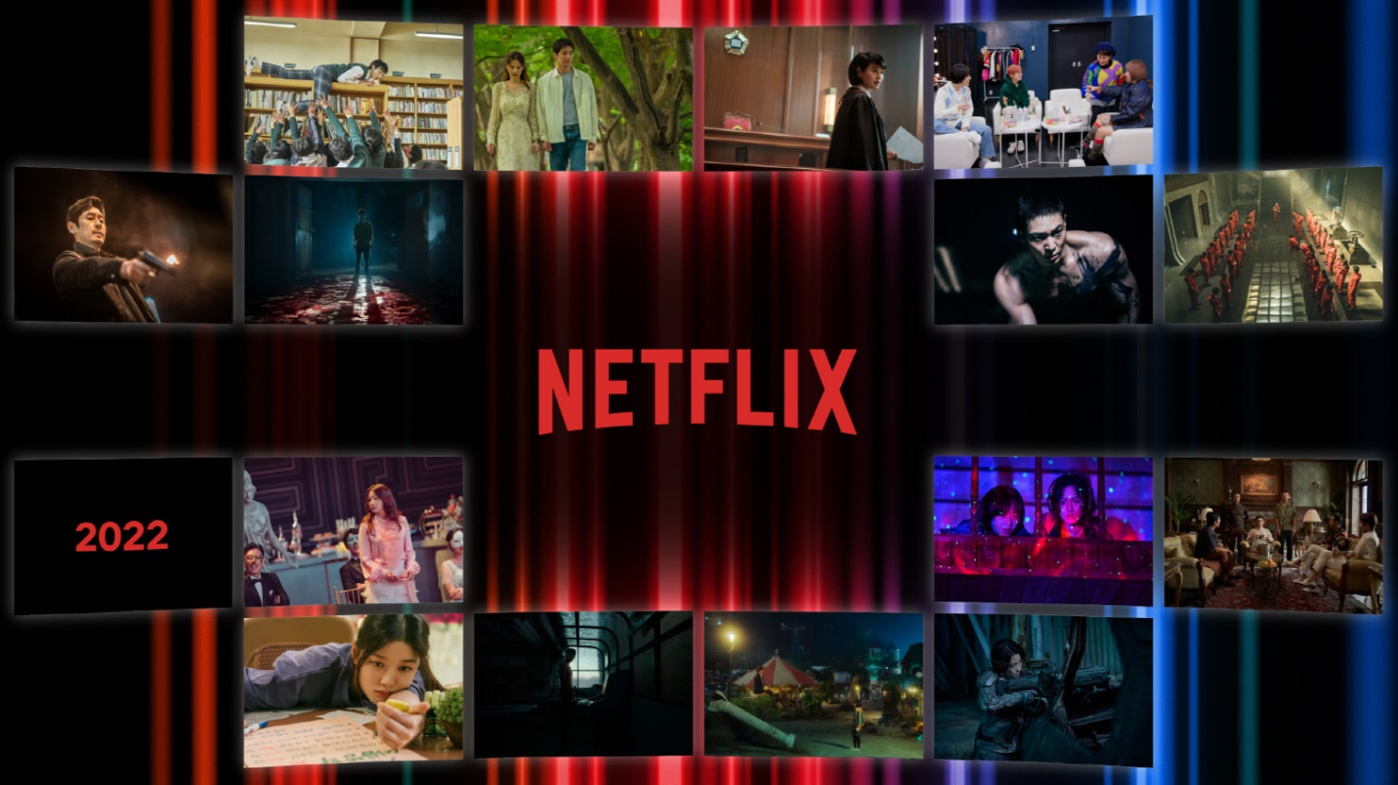

Overview

Netflix is one of the world's leading entertainment services with 221 million paid memberships in over 190 countries enjoying TV series, documentaries, feature films and mobile games across a wide variety of genres and languages. Members can watch as much as they want, anytime, anywhere, on any internet-connected screen. Members can play, pause and resume watching, all without commercials or commitments.

Goals

1. Login Page

2. Subscription page

3. Payment page

4. Streaming page

5. Login and Logout page

History

**History of Netflix has consistently innovated in streaming video. Over the history of Netflix, the company has maintained a content catalogue which would be delivered at first via mail. When the technology infrastructure became available Netflix pioneered video technology, which revolutionised home-based video entertainment. The technical decisions that Netflix takes often serve as guides for VdoCipher’s course of action, while the long-term vision that the company has executed in its two decades has helped it standout from competition. Netflix offers a fantastic glimpse into how long-term strategy and decision-making ensured the company crested the wave of vastly increased internet connectivity in recent years**.

**Technologies used in Netflix**

Front-End:

1. Html
2. CSS
3. BootStrap
4. JavaScript

Code Compilers:

1. Visual Studio Code
2. Git Bash
3. Git Hub

Github json link: